*­­­­­­Getting started with AWS CloudFormation*

AWS CloudFormation is a service that helps you model and set up your AWS resources so that you can spend less time managing those resources and more time focusing on your applications that run in AWS. You create a template that describes all the AWS resources that you want (like Amazon EC2 instances or Amazon RDS DB instances), and CloudFormation takes care of provisioning and configuring those resources for you. You don't need to individually create and configure AWS resources and figure out what's dependent on what; CloudFormation handles that.

In this tutorial, you will be making use of the provided YAML template to create a CloudFormation stack consisting of an Amazon EC2 instance with simple properties. Thereafter, you will be updating the stack by adding Input Parameters and additional resources including Elastic IP and Security Groups.

Following are the steps to be performed:

* Step 1: Pick a template
* Step 2: Create the initial stack
* Step 3: Monitor the progress of stack creation
* Step 4: Update the stack
* Step 5: Monitor the progress of stack updating
* Step 6: Clean up

# Step 1: Pick a template

A CloudFormation template is a JSON or YAML formatted text file. You can save these files with any extension, such as .json, .yaml, .template, or .txt. CloudFormation uses these templates as blueprints for building your AWS resources.

1. Download the sample YAML template by clicking [here](https://drive.google.com/file/d/1cv61J0aaMUtbnEbLohbQhSVlBz_7gz45/view?usp=sharing), and use notepad or any text editor to open the downloaded template.

1. Upon opening, you can easily view and go through the contents of this template.

* If you use this template to create a stack, AWS CloudFormation will launch an Amazon EC2 instance.
* Resources declarations use Properties attribute to specify the information used to create a resource.
* Depending on the resource type, some properties are required such as AvailabilityZone, ImageID and InstanceType for an AWS::EC2::Instance resource, and others are optional.

# Step 2: Create the initial stack

Now, you will be using the above template to create your initial stack.

### To create a stack on the CloudFormation console:

1. Login to AWS Management Console and search for CloudFormation via the search bar provided at the top, and click the search result to get to the CloudFormation dashboard.

1. Once you land to CloudFormation console, click **Create Stack**.

After starting the Create Stack wizard, you specify the template that you want AWS CloudFormation to use to create your stack.

CloudFormation templates are JSON- or YAML-formatted files that specify the AWS resources that make up your stack.

### To choose a stack template

1. For **Prepare template**, make sure **Template is ready** remains selected.

1. In the **Specify template** section, select **Upload a template** file to select a CloudFormation template on your local computer.

1. Click**Choose File** to select the downloaded template file. Once you have chosen your template, CloudFormation uploads the file and displays the S3 URL.

1. To accept your settings, choose **Next**, and proceed with [specifying the stack name and parameters](https://docs.aws.amazon.com/AWSCloudFormation/latest/UserGuide/cfn-using-console-create-stack-parameters.html).

After selecting a stack template, specify the stack name and values for the parameters that were defined in the template.

### To specify the stack name and parameter values

1. On the **Specify stack** details page, type a stack name in the **Stack name** box, leave the **Parameters** section blank (as there are no parameters defined in your template), and choose **Next** to proceed with settings options for your stack.

1. For this hands-on, there is no need to configure stack options. Hence, accept default values for options listed on this page.

1. Scroll down to the bottom of this page and click **Next** to proceed with reviewing your stack.

The final step before your stack is launched is to review the values entered while creating the stack. You can also estimate the cost of your stack.

1. On the **Review** page, review the details of your stack.

If you need to change any of the values before launching the stack, choose **Edit** on the appropriate section to go back to the page that has the setting that you want to change.

1. Since no values need to be changed for this hands-on, scroll down to the bottom of this page and click **Create** **stack** to launch your stack.

### Step 3: Monitor the progress of stack creation

1. CloudFormation displays the **Events** pane of the **Stack details** page for your new stack.

From here, you can [view your stack's events, data, or resources](https://docs.aws.amazon.com/AWSCloudFormation/latest/UserGuide/cfn-console-view-stack-data-resources.html). CloudFormation automatically refreshes the stack events every minute. Additionally, CloudFormation displays the **New events** **available** badge when new stack events occur; choose the refresh icon to load these events into the list. By viewing stack creation events, you can understand the sequence of events that lead to your stack's creation (or failure, if you are debugging your stack).

While your stack is being created, it's listed on the **Stacks** page with a status of **CREATE_IN_PROGRESS**.

1. After your stack has been successfully created, its status changes to **CREATE_COMPLETE**. You can then choose the **Resources** tab to view the list of resources deployed in this stack.

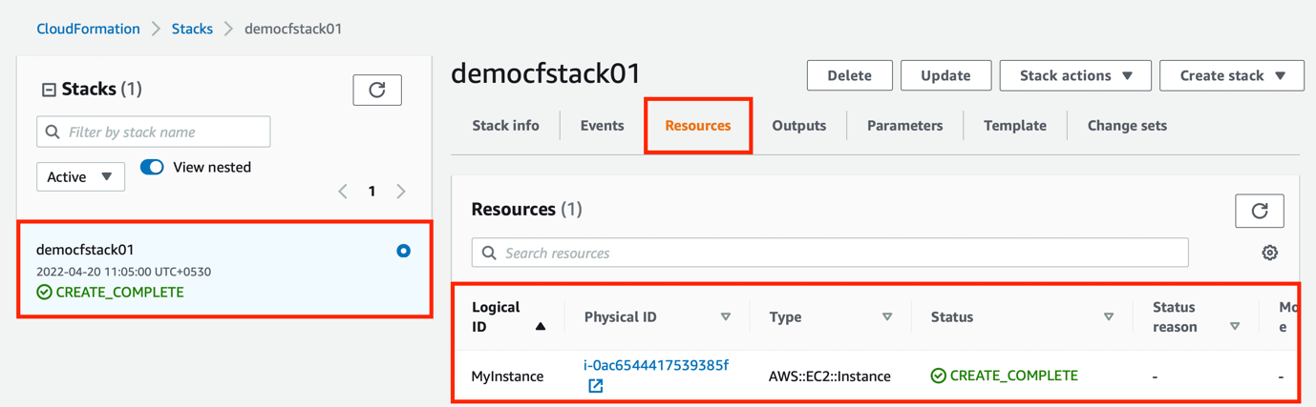

### Step 4: Update the stack

When you want to quickly deploy updates to your stack, perform a direct update. With a direct update, you submit a template or input parameters that specify updates to the resources in the stack, and AWS CloudFormation immediately deploys them. If you want to use a template to make your updates, you can modify the current template and store it locally or in an Amazon S3 bucket.

1. For this update, [click here](https://drive.google.com/file/d/1GYGzTrCExy6tts-cfM0nXqdgRBhIa3Kr/view?usp=sharing) to download the modified template with resources added such as two separate security groups and an elastic IP, and a parameter to provide description for one of the security groups.

Another security group will be created with ingress rules and attached to newly launched EC2 instance

A security group will be created with an ingress rule and attached to newly launched EC2 instance

An Elastic IP will be allocated and the associated with the newly launched EC2 instance­­

A replacement EC2 instance (while terminating previous one) will be launched with two new security groups attached to it

An input parameter is added here to provide a description for second EC2 Security Group

1. In the stack details pane, choose **Update**.

1. Select **Replace current template** to specify the location of the updated template in the **Specify template** section.

1. Since the modified template is stored locally on your computer, select **Upload a template** file. Click **Choose file** to navigate to the file and select it, and then choose **Next**.

1. On the **Specify stack details** page enter a description for your second security group, and then choose **Next**.

1. On the **Configure stack options** page, you can update the tags and permissions applied to the stack, and modify advanced options such as stack policy, rollback configuration, or update the Amazon SNS notification topic.

1. To update your stack, you don’t need to add or change any value or any given option on this page. Hence, scroll down to the end of this page and click **Next**.

1. Review the stack information and the changes that you submitted.

In the **Change set preview** section, check that AWS CloudFormation will make all the changes that you expect. For example, you can check that AWS CloudFormation adds, removes, and modifies the resources that you intended to add, remove, or modify. AWS CloudFormation generates this preview by creating a change set for the stack

1. When you are satisfied with your changes, choose **Update stack**.

### Step 5: Monitor the progress of stack updating

1. CloudFormation displays the stack details page for your stack, with the **Events** pane selected. Your stack now has a status of **UPDATE_IN_PROGRESS**.

Following is the expected outcome of this update:

1. Two security groups SSHSecurityGroup and ServerSecurityGroup will be created with ingress rules.
2. An elastic IP MyEIP will be generated.
3. The existing EC2 instance MyInstance will be terminated.
4. A new EC2 instance MyInstance will be launched as a replacement while attaching newly created resources such security groups (SSHSecurityGroup and ServerSecurityGroup) and elastic IP (MyEIP) to it.

1. After CloudFormation has successfully finished updating the stack, it sets the stack status to **UPDATE_COMPLETE**.

If the stack update fails, CloudFormation; automatically rolls back changes, and sets the stack status to **UPDATE_ROLLBACK_COMPLETE**.

1. Choose the **Resources** tab to view the list of resources deployed in this stack

1. To verify these resources on EC2 dashboard, type **EC2** on the search bar, and click on the search result.

1. You can now see the list of two EC2 instances: the terminated one and the one launched afresh as a replacement.

1. Select the running EC2 instance while the **Details** tab gets selected automatically.

Here you can view the *Instance summary* to check and confirm that an Elastic IP is being associated with this virtual machine.

1. Go to the **Security** tab to access and retrieve the list of two security groups (along with their ingress and egress rules) attached to this very EC2 instance.

### Step 6: Clean up

You have completed the hands-on. To make sure you aren't charged for any unwanted services, you can clean up by deleting the stack and its resources.

### To delete the stack and its resources

1. From the CloudFormation console, select the stack and choose **Delete**.

1. In the confirmation message that appears, choose **Delete stack**.

1. The status for your stack changes to **DELETE_IN_PROGRESS**. In the same way you monitored the creation of the stack, you can monitor its deletion by using the **Events** tab.

1. When CloudFormation completes the deletion of the stack, it removes the stack from the list.

